MODULE 3: ARTISTIC ELEMENTS

EXAM

The exam is worth a total of 100 points. Questions 1-5 are worth 15 points each. Question 6 is worth 25 points.

Select the BEST term from the list to match to each numbered definition.

1.
Negative

Contrast

Shape

Value

Line

1. A large difference between two things: for example, rough and smooth or white and black.

2. A flat area created by line, color or value. Can be positive or negative.

3. A shape adjacent to a more significant object or form.

4. An element of art that refers to the lightness or darkness of a color.

5. A mark with length and direction, created by a point that moves across a surface.

2.
Space

Complementary

Analogous

Color

Texture

1. The element of art that refers to the surface quality or feel of an object.

2. Element of art produced when a wavelength of light strikes an object and reflects back to the eyes.

3. The empty or open area between, around, above, below and within objects.

4. Another name for related colors. Found next to each other on the color wheel.

5. Colors that are directly opposite each other on the color wheel. When mixed together, they make a neutral gray or brown.

3.
Figure / ground relationship

Point

Positive

Implied

Expressive

1. A shape that defines an actual object.

2. A singularity in space

3. The visual reaction between a mark and the surface it’s created on.

4. Line created by the visual connection between two or more areas.

5. A curved line.

4.
Plane

Form

Spectrum
Secondary

Additive

1. A surface area in space.

2. Visible bands of the sequence of colors.

3. A color created by mixing light.

4. A shape or three-dimensional volume that has or gives the illusion of having weight, density or bulk.

5. A color created by mixing two primaries.

5.
Subtractive

Primary

Cool

Saturation

Warm

1. A color ranging from green to violet on the color wheel.

2. A color created by mixing paints or inks.

3. Colors ranging from yellow to red on the color wheel.

4. A color that can’t be created by mixing.

5. The purity or intensity of a color.

Essay Question: Study the ‘Vishnu Mandala’ painting from Tibet below. Describe how the artistic elements are integrated into the work. Be sure to reference all the elements in your answer.

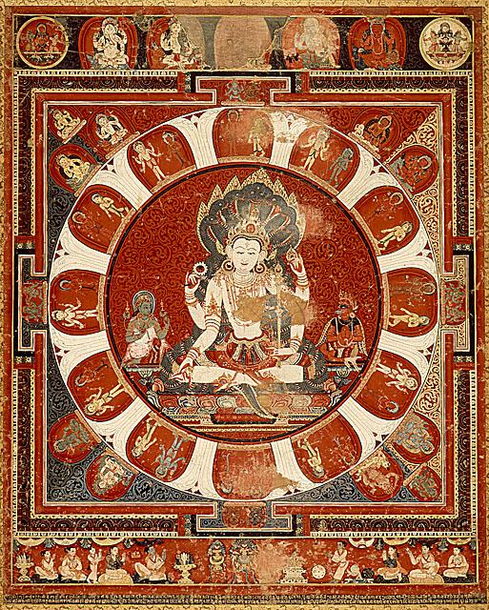

Vishnu Mandala, c. 1450, Nepal.

